Project Development Phase
Performance Test

Date | 25 October 2026
Team ID | Individual
Project Name | EV Market Analysis
Maximum Marks

Project Performance Testing:
Project team shall fill the following information in model performance testing template.
S.No. | Parameter | Screenshot / Values
 | Data Rendered | EV market dataset connected to Tableau and rendered as the "EV Market Analysis" workbook.  Total Sales: 1,550.70M units; CO2 Emission Prevented: 737.93K.  Model years 2018–2026; 15 vehicle categories (Two-Wheeler Scooter to Luxury SUV); 5 battery technologies (LFP, NMC, NCA, Sodium-Ion, Solid-State); manufacturers, manufacturing countries, range and customer rating fields.
 | Data Preprocessing | Data source loaded and field data types checked (measures: annual_sales_units, range, customer rating; dimensions: category, battery type, manufacturer, country; Model Year as a date/discrete year).  Records checked for duplicates and null values, and fields renamed/organised before building the sheets.
3. | Utilization of Filters | Top 10 filter on Manufacturer by SUM(annual_sales_units) (Top 10 Manufacturers By Sales, Market Share Top 10).  Top 5 filter on Category by sales (Top 5 Sales Growth by Year).  Model Year, Category, Battery Technology and Manufacturer used as dashboard filters/highlight actions; "Entire View" fit applied.
4. | Calculation fields Used | CO2 Emission Prevented (KPI calculated field).  % Difference in annual_sales_units (table calculation, year over year) for Top 5 Sales Growth by Year.  Market Share % (percent of total of SUM(annual_sales_units)) by manufacturer.  Average Range and Average Customer Rating (AVG aggregations) by category/manufacturer; Total Sales = SUM(annual_sales_units).
5. | Dashboard design | No of Visualizations / Graphs - 13 (plus 2 KPI cards)  Dashboard 1: Electric Vehicle Market Analysis (7): Battery Technology Adoption treemap, Range Over Time heatmap, Annual Sales By Category, Average Range By Vehicle Category, Customer Rating by Category, Top 10 Manufacturers By Sales, Top 5 Sales Growth by Year.  Dashboard 2: Manufacturer Competitive Analysis (6): Battery Technology Distribution pie, Manufacturer Market Share Top 10, Sales by Manufacturing Country map, Annual Sales Trend, Customer Rating by Manufacturer, Rating vs Sales by Manufacturer scatter.  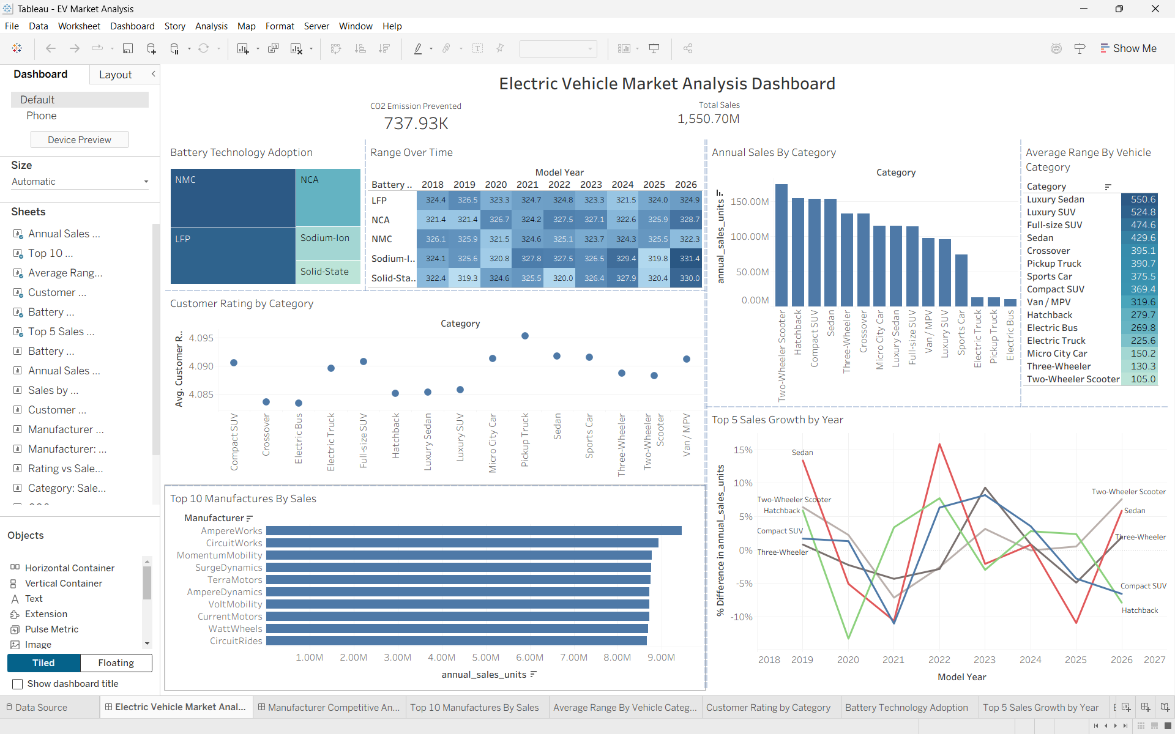  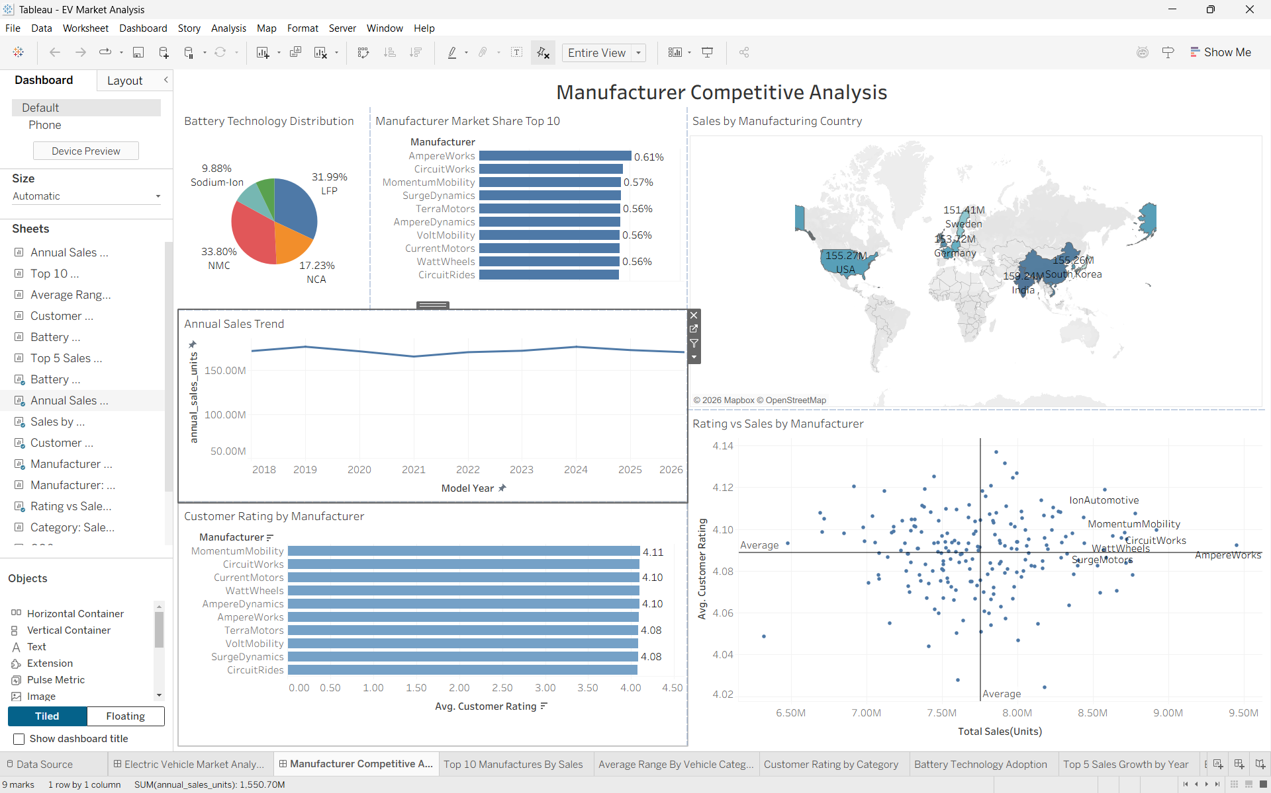
6 | Story Design | No of Visualizations / Graphs - 13  Story built from the two dashboards: Electric Vehicle Market Analysis, then Manufacturer Competitive Analysis (category sales and battery adoption, then manufacturer share, country and rating insights).

